RFI MAPPER
OVERVIEW
RFI Mapper is a data collection program that allows a ham radio mobile (aka vehicle) to collect S Meter readings while the operator drives a route. The collected data can then be mapped using Google MyMaps to show RFI noise sources. For power line noise (PLN), it is usually run on the 10M band, but it can be run on other frequencies if the noise source is specific to a single band. RFIM indicates where the noise sources are located and their intensity. It is then necessary for the ham to decide which noise sources require confirmation and correction.

A sample map showing two hot spots that later turned out to be faulty lightning arrestors. This map quickly zeroed me in on where I should be looking and the fact there was more than one noise source, actually 3, but one was too small to matter from my QTH.
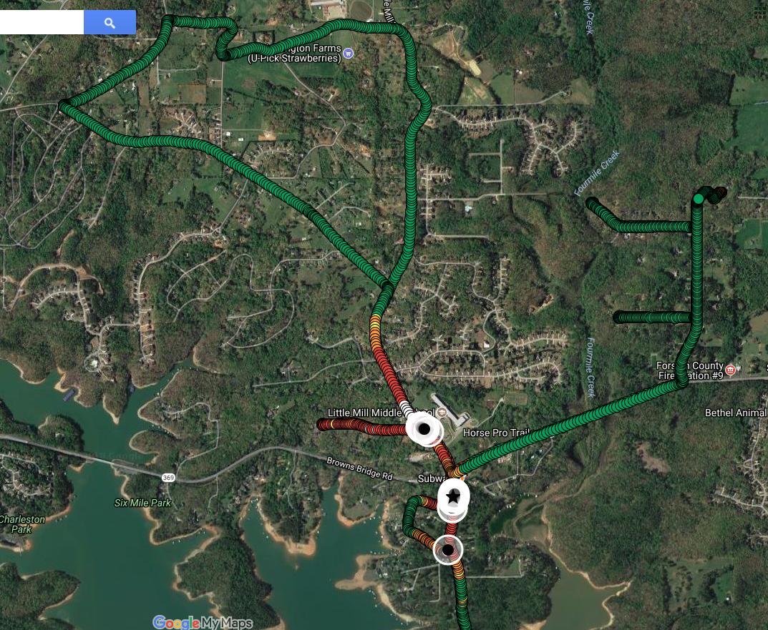

A block diagram of a typical RFI Mapper Installation. Some transceivers combine both a HF receiver and a GPS in one package. In that case, only a laptop and the transceiver are needed, along with a quality HF antenna like a Hamstick for the desired band.
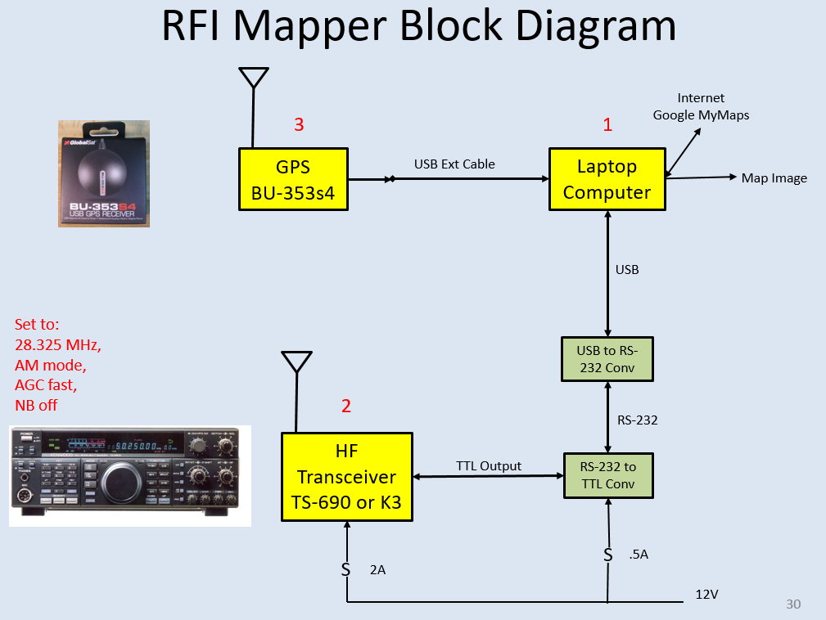

I purchased my initial BU-353s4 GPS in 2015. The 353s3 has been discontinued and replaced by the BU-353N. The 353N is slightly more sensitive than the 353s4 but is also more expensive. Both work well.
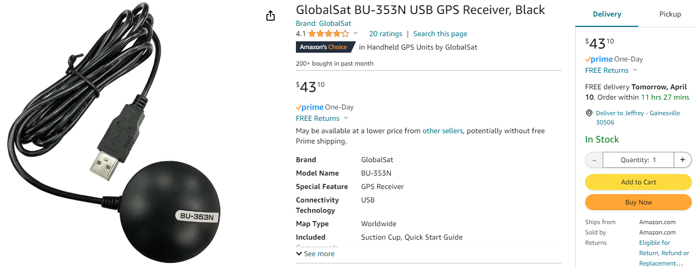
RFIM collects a S meter sample from the antenna on the vehicle every 1 second. It will announce that level every 10 seconds to confirm all is operating well. It will also announce the level when the level of the S Meter goes above S-9. Anything above S-10 is a big noise source and should be investigated.

MAPPING
Google MyMaps is very easy to use. Google MyMaps is not the same as Google Maps.
Maps are generated by uploading the RFIM csv file to Google MyMaps (mymaps.google.com).
You can upload 2,000 data points per layer (up to 10 layers) and turn the 10 Layers on or off.
If the file is over 2,000 samples, which is the MyMaps Layer limit, break the file into 2 parts using MS Excel.
If you generate a second file, make sure it has the column titles in it.
Steps involved in MyMaps Mapping after the data is collected are listed below. Although this seems complicated at first, after a couple of maps it will proceed very fast. Maps can be colored and optimized in 5 minutes. In a very strong RF environment, you may want to shift the colors to higher values. When looking for weak noise sources, you can shift the colors lower in the scale. The map will indicate where the noise sources are, and just as important, where they are not.
- Log in to Google MyMaps (MyMaps.Google.com)
- Click CREATE A NEW MAP. This will create a directory that will hold up to 10 maps.
- Click IMPORT
- Click BROWSE
- Select the .csv file that contains your data. It is in the C:\RFI_DATA directory.

- LATITUDE and LONGITUDE will be preselected. Click CONTINUE.
- Click SAMPLE to title your markers (SAMPLE Is the Sample number contained in the CSV file).
- The Data will be loaded
- Click UNIFORM STYLE to get a list of ways to color.
- In the box for Group Places By, click S-MTR. You will be returned to the signal level menu.

- Place your cursor over the first signal level and click the PAINT CAN to the right.
- Click MORE ICONS
- Click OLDER ICONS in the lower right corner.
- Click the CIRCLE at the top, then OK. This will add the circle to your icon list.

- Now select the circle, and select the dark green color.
- Click the X in the upper right of the box to close that signal level.
- Color other signal levels similar to the chart below.
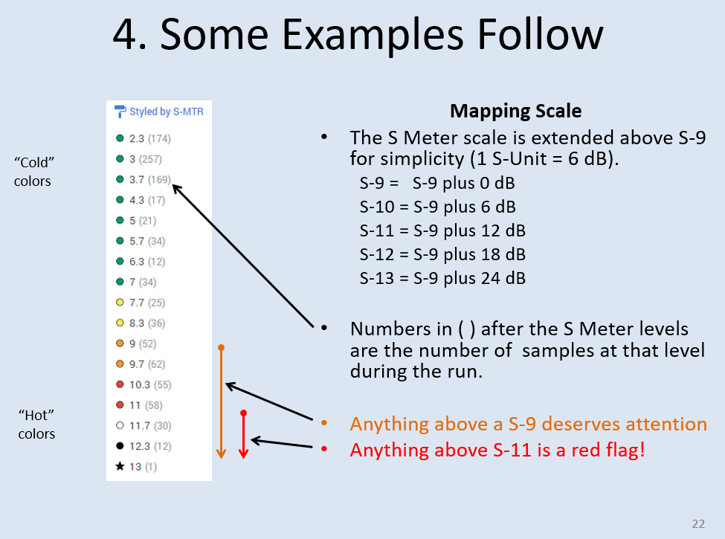
RFI MAPPER (RFIM) INSTALLATION
Directions for installing RFI Mapper. The C:\RFIM folder will eventually have 4 files in it.

A: SETTING UP THE RFIM DIRECTORY
1. Make a Directory C:\RFIM to hold the 4 files.
2. Drag and drop the following 4 files into the C:\RFIM folder
RFIM User Guide
RFIM Release Notes
RFIM.exe
RFIM.cfg
3. Establish a shortcut on your desktop by right clicking on the exe file and dragging it to your desktop.
4. Make a Directory C:\RFI_Data to hold the RFI files that will be created when the program runs.

B: MODIFYING THE CFG FILE
1. Using Windows Notepad, edit the RFIM.cfg file.
Set the RADIO_TYPE:
Set the GPS_TYPE:
Set the RADIO_PORT: (to what Windows assigned to the Radio in Device Manager)
Set the GPS_PORT: (to what Windows assigned to the GPS in Device Manager)
Set RADIO_CONNECTED:1 (this tells the program a real radio is connected)
Set GPS CONNECTED:1 (this tells the program a real GPS is connected)

2. Save the RFIM.cfg file and close Notepad.

C: RUNNING RFIM
1. Always plug the Radio and GPS into the same USB connector so they get the same COM assignments.
2. When ready to run RFIM, right click on the Icon and select OPEN.
Note that some HF transceivers (like the IC-705) require a special driver loaded on the laptop. The driver will allow access to both the CAT port and GPS port over the same USB cable. Refer to the manufacturer’s web site for newest version of the file and installation instructions. You can test the driver with logging programs like N1MM or a terminal program like TeraTerm.

MISC NOTES

PURPOSE: Collects S Meter samples from a ham radio transceiver while driving to assist in locating Radio Frequency Interference (RFI).
HARDWARE: Laptop computer (Win 10), GPS unit BU-353s4 (or 353N), HF transceiver (Kenwood TS-690), vehicle with HF whip antenna (10M Hamstick).
SOFTWARE: The RFIM.exe program that collects data samples (Lat/Long, S-Meter readings, and elevation) and the RFIM.cfg (tells the program what COM ports to use).
TERMINAL PROGRAM: TeraTerm is a simple but good terminal program. Use it to verify radio and GPS connectivity. RealTerm is also a very good program but a bit more complicated.

TRANSCEIVERS
The Kenwood TS-690, TS-450, and Elecraft K3 work very well, as do others
The IC-705 also works but I have found the Micro USB connector to be very sensitive to movement. USB connectivity is lost and the program halts.
Other Kenwood, Icom, and Elecraft radios may also work if they use standard commands.
I've experimented with a SDR dongle, but it is cumbersome running it from the laptop. A simple transceiver works best.

GPS
DEFAULT GPS DATA RATE is 4800 baud
The program increases the GPS baud rate to 115.2kbps to minimize data message serialization delay
The radio msg is very short, less than 10 characters, so serialization delay is small even at low data rates.
If the GPS is stuck in some unusual data rate, you can use your GPS Manufacturers software to set the GPS. For the BU-353, visit globalsat.com.tw and select support.

DRIVE SPEED - At once a second data interval, samples are collected as follows:
10MPH - 15Ft
20MPH - 30Ft, the preferred speed is 20-30 MPH, but speeds up to 40MPH provide good resolution
30MPH - 45Ft
40MPH - 60Ft
50MPH - 75FT

OTHER SETUP INFO
COM PORTS: Windows assigns COM ports. You can get the COM Port assignments from Windows Device Manager.
Always plug the GPS And radio into the same USB port so the same COM Ports are assigned.
GPS PLACEMENT: For maximum accuracy, the GPS should be placed on the roof of the vehicle, passenger side.
RADIO PARAMETERS: Set Rx frequency near 28.650. Set Mode to AM, Bandwidth to 6KHz, AGC FAST, RF Gain Control at 100, Noise Blanker OFF.
I suggest starting a new file name after an hour or so (about 3,600 samples). Use a different file name.

WINDOWS 10 VOICE: The Voice speed can be changed. Speed it up by 2-3 notches or it takes too long to announce levels which can backlog the announcements.
Voice speed can be adjusted at:\Windows\SysWOW64\Speech\SpeechUX\sapi.cpl
LAPTOP DISPLAY: Suggest setting the Desktop to black to conserve battery power. Suggest setting screen disable to 15 minutes to conserve battery power. Set Laptop Sleep to Never.
CONSOLE WINDOW: If desired, the Console Window font can be adjusted by doing a right click once the Console Window launches. Parameters are retained.

Written by Jeff Stuparits, W4DD
W4DD@arrl.net
Initial Version: v1.00 2015/12/01

